
Name: _______________________________________________________
ID: __________________________________________________________
Section:_______________________________________________________

Question 1 [10 Points]

Write a complete pseudo-code/flowchart of a program that prints the product of all the odd integers between 1300 and 2000. [Answer on the answer-script]

Question 2 [10 Points]

In mathematics, the Fibonacci numbers form a sequence defined by the following 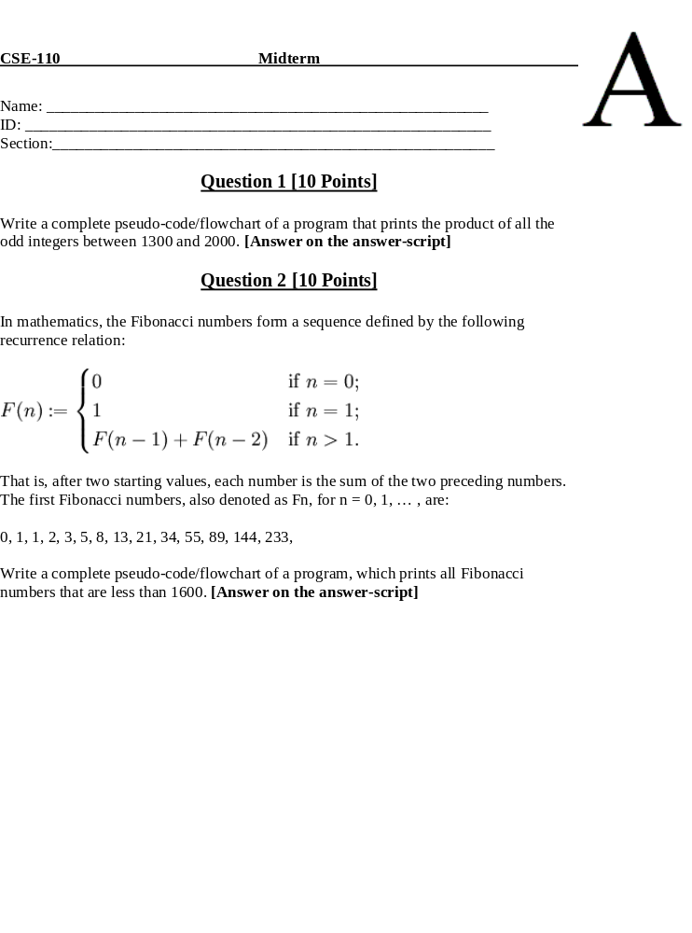recurrence relation:

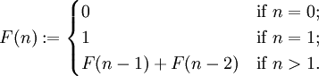

That is, after two starting values, each number is the sum of the two preceding numbers. The first Fibonacci numbers, also denoted as Fn, for n = 0, 1, … , are:

0, 1, 1, 2, 3, 5, 8, 13, 21, 34, 55, 89, 144, 233,

Write a complete pseudo-code/flowchart of a program, which prints all Fibonacci numbers that are less than 1600. [Answer on the answer-script]

Question 3 [10 Points]

public class Q3b
{
public static void main(String args[])
{
int x = 2, p = 1, sum = 0;
double q = 0;
String test = "01";
while (p < 12){
q = x + p - ( q + 7 / 3 ) / 3.0 % 2 ;
sum = sum + (++x) + (int)q;
System.out.println(test + sum + Math.floor(q));
if (x > 5)
p += 4/2;
else
p += 3%1;
}
sum = sum + p;
System.out.println(sum);
}
}

Show the output of the program.

0152.0
01112.0
01193.0
01294.0
01448.0
016210.0
018514.0
0111116.0
0114220.0
155

Question 4 [10 Points]

public class Q4b
{
public static void main(String args[])
{
int test = 1;
int j = 0, k = 100;
while (k > 0){
while (j < k ){
test = k - j + 21;
System.out.println(1 + test / 2 +"11");
j+=10;
}
k-=10;
}
}
}

Show the output of the program.

6111
5611
5111
4611
4111
3611
3111
2611
2111
1611

Question 5 [10 Points]

public class Q5b
{
public static void main(String args[])
{
String test = "";
int i = 5, j = 0, k = 15;
while (i < 10){
k-=1;
j = k;
while (j > 10 ){
if ((j % 2 != 0) && (i < 7)){
test = "<--";
test = test + i + 3.2 + "-->" + (double)((j + 2) / 2.0);
}else{
test = "-->";
test = "-->" + ((i - 2) / 2) + test + (j - 2);
}
System.out.println(test);
--j;
}
i++;
}
}
}
Show the output of the program.

-->1-->12
<--53.2-->7.5
-->1-->10
<--53.2-->6.5
<--63.2-->7.5
-->2-->10
<--63.2-->6.5
-->2-->10
-->2-->9
-->3-->9

Question 6 [10 Points]

public class Q6b
{
public static void main(String args[])
{
boolean var1 = false, var2 = false, var3 = false, var4 = false,var5 = false;
boolean var6 = false, result1 = false, result2 = false, result3 = false, result4 = false;
boolean result5 = false, result6 = false, result7 = false, result8 = false;
boolean result9 = false, result10 = false;
var1 = (!false || false) && true;
var2 = var1 && true;
var3 = false && !true;
var4 = true;
var5 = false;
var6 = var3 && true;
result1 = (var1 && var2) && ( 40 % 3 > 45) || (var5 && var6);
result2 = (var1 || var2) || (result1 && true);
result3 = (var1 && result1) || result2 || var5;
result4 = (var1 || var2) || ((var3 && var1) && true);
result5 = (var1 && var2) && (result3 || var1);
result6 = ((var3 || !var2) && (result5)) || false;
result7 = (var4 && result1) && ((result1 && true) || false);
result8 = ((var1 && result3) && (!var5 || var6)) && false;
result9 = ((result2 && var2) || (!result7 && var1)) && !true;
result10 = !(var1 && false);
}
}

Show the values of the result variables in the above program:

result1 | false
result2 | true
result3 | true
result4 | true
result5 | true
result6 | false
result7 | false
result8 | false
result9 | false
result10 | true

